Vulnerability Analysis

Table of Contents
1. Executive summary
2. Scope of Testing
3. Graphical Summary
4. Discovered Vulnerability Details
4.1. SQL Injection
4.1.1. Details of Vulnerability
4.1.2. Steps to Reproduce
4.1.3. Proof of Concept
4.1.4. Suggested Remedies
4.2. Cross Site Scripting
4.2.1. Details of Vulnerability
4.2.2. Steps to Reproduce
4.2.3. Proof of Concept
4.2.4. Suggested Remedies
4.3. Security Misconfiguration
4.3.1. Details of Vulnerability
4.3.2. Steps to Reproduce
4.3.3. Proof of Concept
4.3.4. Suggested Remedies
4.4. Broken Access Control
4.4.1. Details of Vulnerability
4.4.2. Steps to Reproduce
4.4.3. Proof of Concept
4.4.4. Suggested Remedies

4.5. Broken Authentication
4.5.1. Details of Vulnerability
4.5.2. Steps to Reproduce
4.5.3. Proof of Concept
4.5.4. Suggested Remedies
5. Conclusion

EXECUTIVE SUMMARY

This examination was done to identify security gaps, faulty business logic, and omitted basic security practices. The application or network's functioning was not harmed throughout the testing, which were conducted under the guise of an attacker or a malicious user.

Scope of Testing

Security evaluation involves testing for security loopholes using various web applications like bWAPP (Buggy Web Application) and DVWA (Damn Vulnerable Web Application) which are specially designed for the developers and students to learn web vulnerabilities using a hands-on approach.

Graphical Summary

The viewers will receive an overall summary of security loopholes, including vulnerabilities discovered, severity, corresponding CVSS Score, and other vulnerability details such as its impact, detailed PoC, steps to reproduce, and suggested fixes, from the graphical representations below from bWAPP and DVWA dashboard.

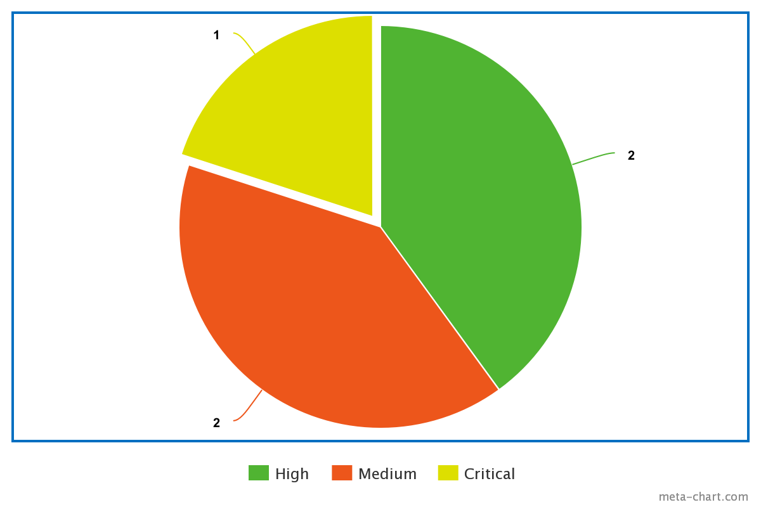Figure 1: Graph: Severity of Bugs

DISCOVERED VULNERABILITIES DETAILS

Vulnerability #1

SQL Injection

Severity : Medium
CVSS Score : 5

Details of Vulnerability

SQL injection flaws typically appear when a program unsafely combines user data into a database query. An attacker can employ data manipulation to make their own database query run, giving them access to read or change the database's contents.

Steps to reproduce

SQL Injection (Get/Search) was performed using bWAPP. In the SQL Injection (Get/Search) section, a JSON parameter was submitted which had a single quote, and an extensive error message was returned. The problem warning then vanished once two single quotes were entered. If there is a vulnerability, users should check the error message's text and how the application handles other input.

The SQL Injection was carried out using the following payloads :
1. “' and 1=0 union all select 1,table_schema,table_name,4,5,6,7 from information_schema.tables where table_schema != 'mysql' and table_schema != 'information_schema' -- - “

This payload when submitted viewed if the user table exists in the database.

2. “ ' and 1=0 union all select 1,table_name, column_name,4,5,6,7 from information_schema.columns where table_schema != 'mysql' and table_schema != 'information_schema' and table_schema='bWAPP' and table_name='users' -- - “

This payload disclosed the list of users in the database.

3. “ ' and 1=0 union all select 1,login,password,secret,email,admin,7 from users-- - “

This payload retrieves all of the user’s data from the database.

Proof of Concept :
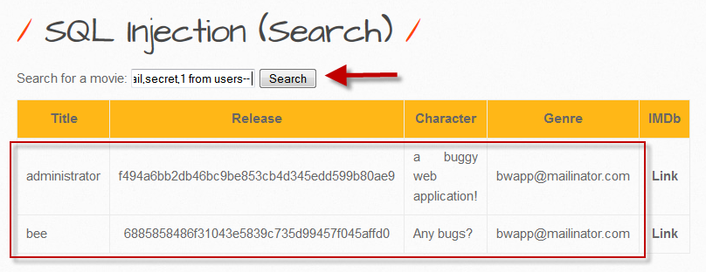

Suggested Remedies :

1. Ready-Made Statements (with Parameterized Queries) - All developers should first learn how to build database queries using prepared statements with variable binding, also known as parameterized queries. They are less complicated to create and comprehend than dynamic queries. The developer must first define all the SQL code for parameterized queries before passing each parameter to the query. No matter what user input is provided, the database can tell the difference between code and data thanks to this coding approach.

2. Allow-list Validation of Input - Some areas of SQL queries, such as names of tables or columns and the sort order indicator, are not permitted for the use of bind variables (ASC or DESC). The best defense in these cases is input validation or query redesign. Ideally, the values for table or column names originate from the code rather than from user parameters. (Sharma, 2022)

Vulnerability #2

Stored Cross-Site Scripting (XSS)

Severity : High
CVSS Score : 7.7

Details of Vulnerability:

Stored XSS Vulnerability was discovered on bWAPP. This makes it possible for a hacker to insert a script that is then stored in the program. The XSS payload will be provided as a component of the website when a victim accesses it in a browser. As a result, when a victim views the page in a browser, they unintentionally end up running the malicious script. Impact: The code provided by the attacker is capable of a wide range of operations,

Impacts :

Cross site scripting assaults can have terrible implications. A susceptible application's code injection vulnerability allows for the installation of malware or the exfiltration of data. Through the use of session cookies, attackers can pretend to be authorized users and carry out any action permitted by the user account.

Moreover, XSS might harm a company's reputation. A corporate website can be defaced by an attacker by changing its content, harming the brand or disseminating false information. In order to influence users' behavior, a hacker can alter the instructions posted on the target website. If the target is a government website or offers essential resources during emergencies, this scenario is especially risky.

Steps to Reproduce :

An XSS – Reflected (Get) attack was carried out on the web application after choosing it on the lists of bugs available. A login page was viewed on which a certain payload was submitted. As a result, an alert windows poped up. Instantaneously, a browser alert that was simply intended to gather data and send to the server is executed. Now, the server is not affected by this because it is only running on the user's browser. Yet, this might be concealed in a URL that directs the user to a legitimate website. If users recognize the domain name and click on it, there is a chance that the script embedded therein will be executed if the website is susceptible to this specific assault.

The XSS attack was carried out using following payload :

1. “<script>alert(“Hello! I am an alert box!!)”

This payload displayed an alert windows after it was submitted in the login page.

Proof of Concept :

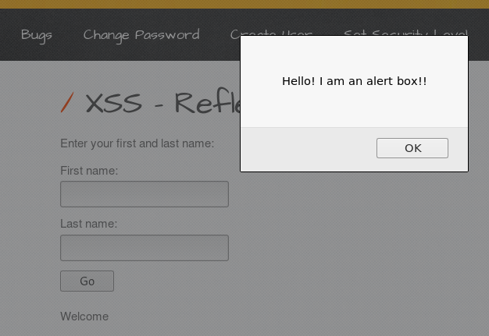

Remedies :
1. The easiest strategy to avoid stored XSS attacks is to process user input securely in both client-side and server-side code before it is permanently saved on the web server. (Bright, 2022)

Vulnerability #3

Security Misconfiguration

Severity : 6
CVSS Score : Medium

Details of Vulnerability:

The most frequent problem is security misconfiguration, which can be caused by insufficient or default configurations, exposed cloud storage, incorrect HTTP headers, and verbose error messages with sensitive information. All operating systems, frameworks, libraries, and programs must be configured securely, and they must occasionally be patched or upgraded. Attackers can simply access the system by taking advantage of these loopholes when security is configured incorrectly.

Steps to Reproduce :

This security loophole was pointed out using DVWA. The source code for this vulnerability has been constructed in a way that it can accept any file when we upload it rather than only choosing the image that it has specified. When a user attempted to upload a file with the.docx extension in Fig., it indicated that the upload had been successful, and when the user attempted to upload an image file again in Fig., it also indicated that the upload had been successful. The weakness in this situation is that the source code only mentions or restricts files with the image extension.

Proof of Concept :
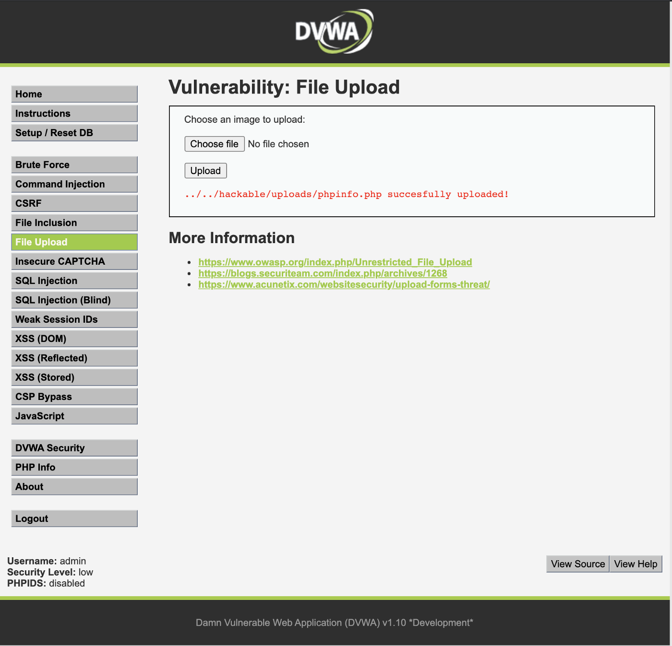

Remedies :

1. In every scenario, install software patches and updates on a regular and timely basis. Also, you can patch a golden image and use it in your environment.
2. Provide an application architecture that provides efficient and secure element separation.
3. Make sure the development cycle is organized and well-maintained. This will make it easier to test the application's security during the development stage. (Pasan,2023)

Vulnerability #4

Broken Access Control

Severity : 7
CVSS Score : High

Details of Vulnerability :

Depending on their demands, access control implies limiting users' access to or viewing of particular areas or pages. Attackers can use these weaknesses to get unauthorized access to functionality and/or data when the authenticated users are not properly restricted on specific privileges or to access certain documents or when the access control is violated.

Steps to Reproduce :

Broken access control is when the access control is gotten around to access the restricted material. The specified papers on this website are only accessible to authorized users. The perpetrator will copy and paste the URL (http://localhost/bwapp/documents/) into the new tab.

Proof of Concept :

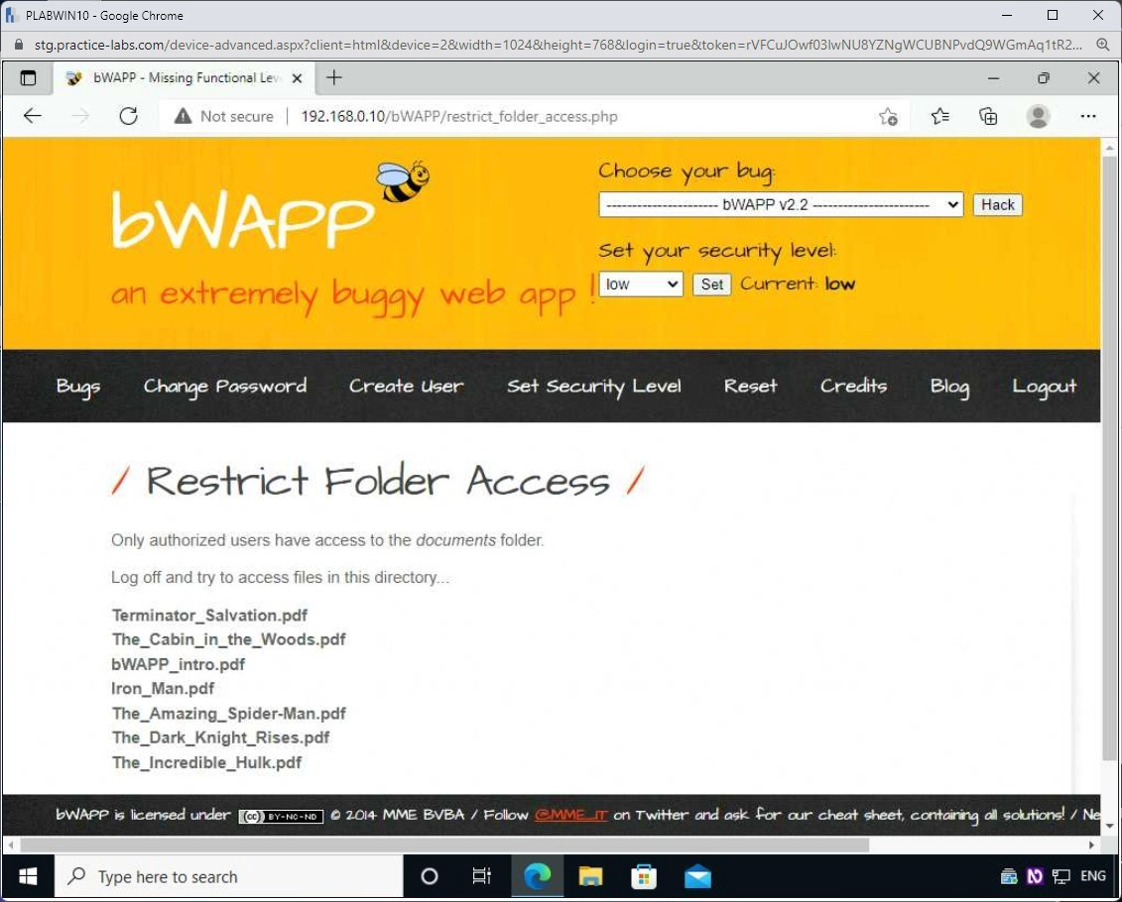

Remedies :

1. Never utilize obfuscation as your only access control strategy.
2. At the code level, specify the level of access that is allowed for each resource, with no access allowed by default.
3. If a resource isn't intended for public use, block access by default.
4. To make sure access control works as intended, audit and extensively test it. (Tashi,2023)

Vulnerability #5

Broken Authentication

Severity : 7.5
CVSS Score : High

Details of Vulnerability :

A web application vulnerability known as Broken Authentication arises from improper session management configuration. A session is formed and activated for the data transmission between the server and the client whenever a user logs into their account, following the completion of the authentication process. In this case, it is referred to as a broken Exploiting Authentication problem of the specific application when the attacker is able to access the active session of a user by circumventing the authentication process.

The user credentials are made available when the user logs into the system. The server will launch a database query when the client-side request is submitted to it in order to confirm the user's provided credentials. A particular session ID will be given to the user after the validation is successful so they can communicate. And the user has access to the services offered.
Browsers will store the user credentials of the authenticated users. The intruder can access the other's active session by using programs like cookie manager, eat my cookie, and advanced cookie manager+.\

Steps to Reproduce :

This security loophole was testes using bWAPP. If the session is active during a broken authentication attempt, the attacker will use applications to steal cookies from browsers before accessing the source code of the specific web page, which will reveal the username and password in plain text, to obtain the login username and password information.

Proof of Concept :
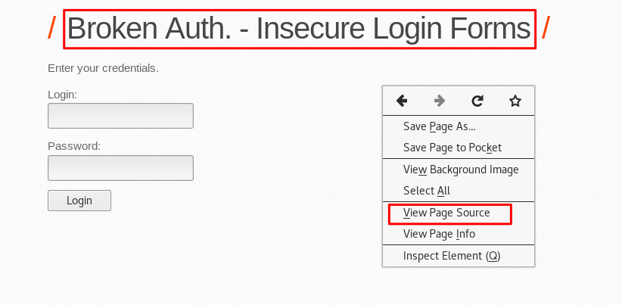

Remedies :

1. Multi-factor authentication (MFA) should be used to confirm the customer's identity. Examples include sending the user a One-Time Password (OTP) by email or text message. By taking this action, you can stop brute force attacks, credential stuffing, and reused attacks using stolen credentials.
2. Limit the number of failed login attempts to a maximum of three. Every type of attack, including brute force and credential stuffing, should be reported to the system administrator. (Gupta,2022)

Conclusion

This study's overall finding is that web application penetration testing is a crucial tool for security experts. They can use it to find web application vulnerabilities and put security controls in place to lessen the dangers brought on by these vulnerabilities. Security experts may effectively audit a web application to make sure it is secure by using a variety of security tools and approaches. Organizations can safeguard themselves from potential threats and guarantee the security of their online applications by discovering and fixing vulnerabilities.

References

1. Sharma, S. (2022, June 17). Penetration testing report by Astra Security [Download Report]. Astra Security Blog. Retrieved February 21, 2023, from https://www.getastra.com/blog/security-audit/penetration-testing-report/

2. 20cross%20site.“What Is XSS? Impact, Types, and Prevention.” Bright Security, 4 Apr. 2022, brightsec.com/blog/xss/#:~:text=If%20successful%2C%20a%

3. pasan.premaratne. “Reflected Cross Site Scripting (XSS) with BWAPP - Randomtecharticles.com.” Bright, 23 Sept. 2019, randomtecharticles.com/reflected-cross-site-scripting-xss-with-bwapp/. Accessed 21 Feb. 2023.

4. Tashi, Jamyang. “Study on Web Penetration Testing, Vulnerability Assessment and Preventive Measures.” IJSTE -International Journal of Science Technology & Engineering |, vol. 7, 2021, pp. 2349–784, www.ijste.org/articles/IJSTEV7I9015.pdf. Accessed 22 Feb. 2023.

5. gupta, deepak. “What Is Broken Authentication and How to Prevent It | LoginRadius Blog.” Www.loginradius.com, www.loginradius.com/blog/identity/what-is-broken-authentication/.

